Assignment 4: Comfort
Goal of the assignment
- To get acquainted with comfort research
- Experience the use of comparing two situations (instead of just asking on the comfort in one situation)
- See that there is a difference between first impression and comfort recording after experiencing the situation

Assignment
You have to perform an experiment with a typing task in two positions. Goal of the experiment is on the one hand to find out how well you are able to predict comfort, on the other hand to discover which position is more suitable for the typing task.

Do this assignment with a group of 4 persons.

Make a test protocol based on the following text and then divide tasks:
- Who will be test subjects: which 2 start lying, which 2 sitting?
- The other will be test leader

Do the experiment:
- First ask the test subjects to complete the first side of the test form.
- Then let 4 subjects take position and ask them to type the text on their smart phone (whatsapp, sms or email) and let them send this to one of the test leaders (one test leader is for lying and the other for sitting). The text is shown at the end of the assignment.
- At the end the subjects complete page two of the questionnaire.

After the test: complete the following table by calculating

 | lying (std) |  | sitting (SD)
number of subjects | 4 |  | 4
 | average | standard deviation | average | standard deviation
score for productivity at first sight (1-7)
score for comfort at first sight (1-7)
number of typed words
number of typed characters (incl spaces)
number of mistakes
score for productivity after test (1-7)
score for comfort after test (1-7)
Evaluate your results:
- Describe your key findings.
- How do you interpret your results?
- What might be explanations for your findings?
- Also, describe doubts or weaknesses in relation to the results and explain their implications.
- If needed, support your argumentations with drawings.

This side first!!!

Nationality: ……….…
Age: ………………..…… Stature: …………………

Evaluation of the productivity at first sight
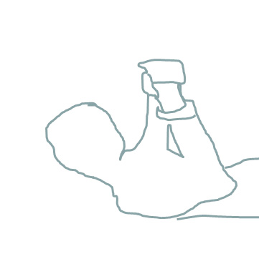
Please indicate how you estimate your performance in a smart phone
typing task if you would lay in the position like on the picture shown
(+pillow)

The productivity is
low |  |  | Moderate |  |  | high
□  1 | □  2 | □  3 | □  4 | □  5 | □  6 | □  7

This position is comfortable
Not at all |  |  | Moderately |  |  | Extremely
□  1 | □  2 | □  3 | □  4 | □  5 | □  6 | □  7

Evaluation of the productivity at first sight
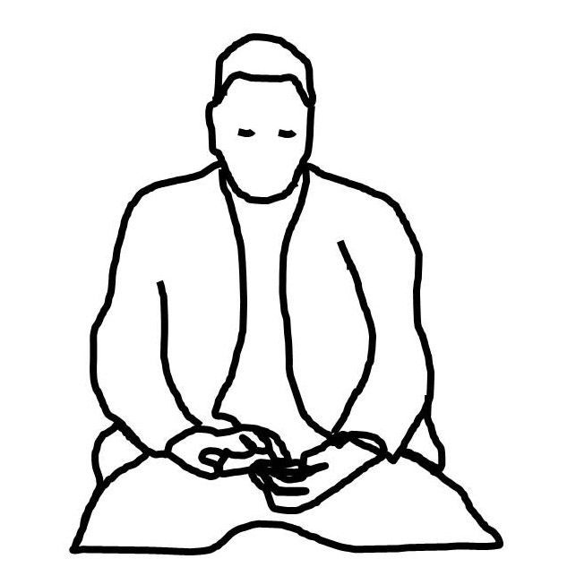
Please indicate how you estimate your performance in a smart phone typing
task if you would sit in the symmetric position like on the picture shown

The productivity is
low |  |  | Moderate |  |  | high
□  1 | □  2 | □  3 | □  4 | □  5 | □  6 | □  7

This position is comfortable
Not at all |  |  | Moderately |  |  | Extremely
□  1 | □  2 | □  3 | □  4 | □  5 | □  6 | □  7

This side after the test!!!

I first took the posture: O lying
O sitting
The experienced productivity in this position is
low |  |  | Moderate |  |  | high
□  1 | □  2 | □  3 | □  4 | □  5 | □  6 | □  7

This position is comfortable
Not at all |  |  | Moderately |  |  | Extremely
□  1 | □  2 | □  3 | □  4 | □  5 | □  6 | □  7

My second posture was: O lying
O sitting
The experienced productivity in this position is
low |  |  | Moderate |  |  | high
□  1 | □  2 | □  3 | □  4 | □  5 | □  6 | □  7

This position is comfortable
Not at all |  |  | Moderately |  |  | Extremely
□  1 | □  2 | □  3 | □  4 | □  5 | □  6 | □  7

Finally
For fast texting I prefer the posture: O lying
O sitting
Comment: .………………………………………………………………………………………………
……………………………….………………………………………………………………
Text to type

Lying/Sitting I am typing a text. It could be an interesting experience using a smartphone. On the other hand others might not be interested in this. It is a kind of testing what the best posture is. I have no choice. Peter Vink made me do this text typing. I use a smart phone in this position. Some people might like it and others not. Anyhow I do it. It is part of an experiment in Elementary Ergonomics. Which is a part of the study industrial design. I have had nicer assignments, but this is life. At the end of this experiment this text is typed.

