

Mobile Gardens

Wilhelm Schütze

Luis Sierra

**Social Cohesion Design Workshop 24 – 29 September 2012 at PUCP, Lima, Peru, realized by the Faculty of Industrial Design (Eduardo Ajito)**

**From PUCP and the Social Cohesion Design Foundation, Delft, Holland (Clemens de Lange) for the Grijsen Company, Winterswijk, Holland**

**Index**

1. Group introduction
2. Project description
3. Social cohesion design mission
4. Identification I-1

* Selecting Setting X, Elements, Actors, Events
* 3D scenario Board
* Sub-Scenarios

1. Integration 1-2

* Selecting most promising Sub-Scenario – Combinations applying a Sub matrix tool.
* Designing Concept in Main Scenario

1. Implantation I-3

* Elaborate on “Look and Feel” to communicate Social mission/ name Advertising Slogan
* 3D CAD drawing of design

**GROUP INTRODUCTION**

Team members:

WILHELM ALFRED SCHÜTZE AURICH

LUIS ARMANDO SIERRA DEL ÁGUILA

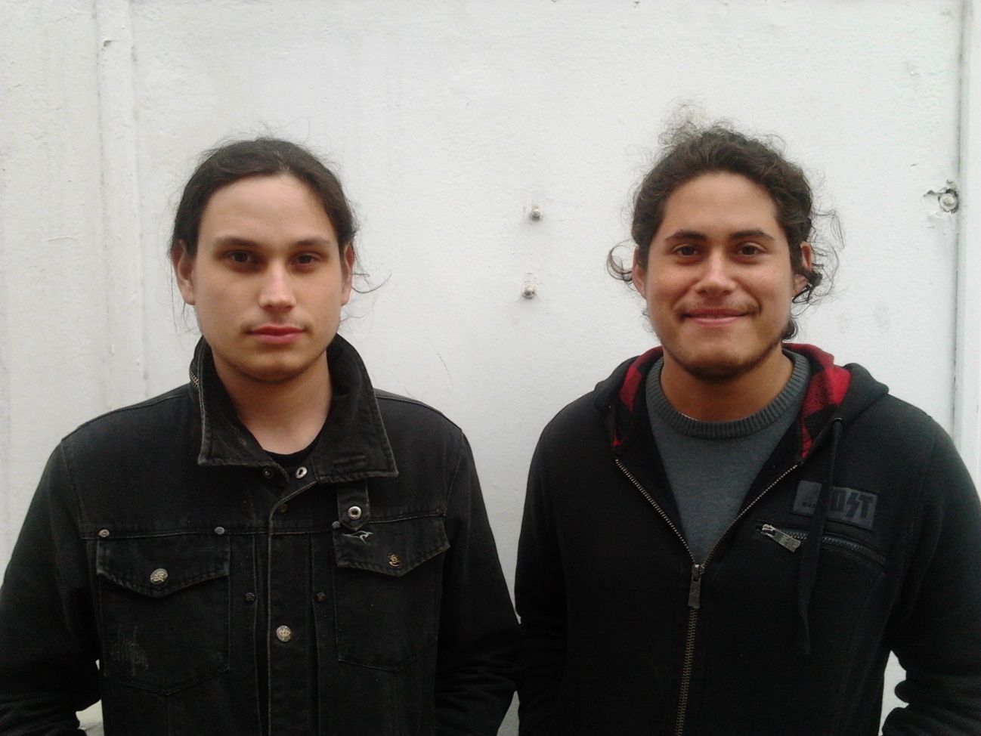

**Group dynamics and organization**

Our design studio is a study that consists of two industrial designers, who are in constant search of a human and technological development in society that allows everyday integrate with an aesthetic experience in the city at a time Offer him a better quality of life through innovation and good taste.

Is for this reason that the combination of design and society is the premise of our work, create urban spaces that promote social development has always been the concern and the reason for our design.

However we also have the support of various multidisciplinary teams that include specialists in graphic design, anthropology, business management, administration and marketing, complementing in a comprehensive study proposals.



Studio logo

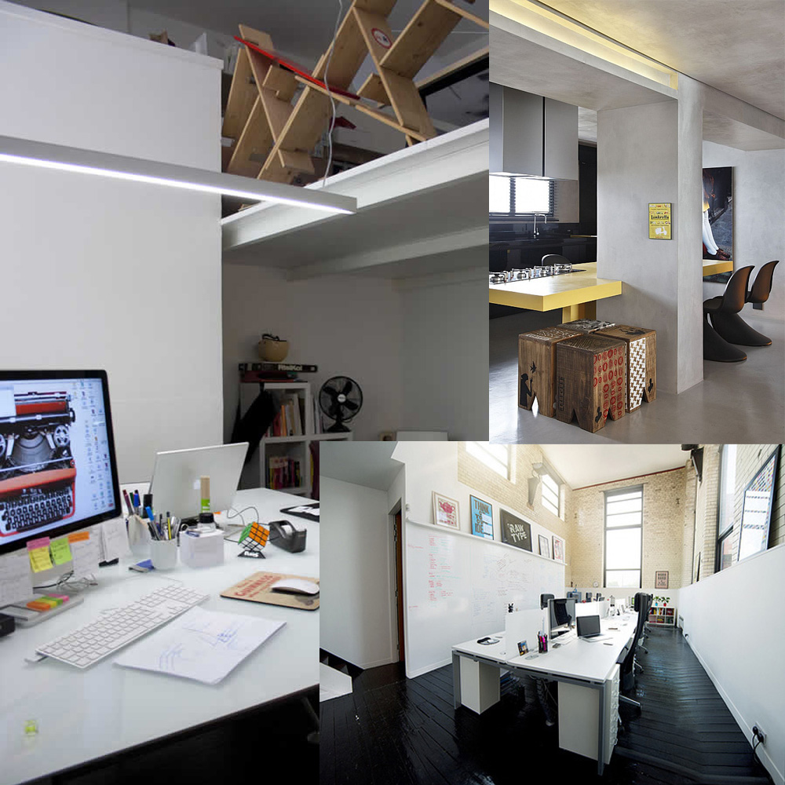

Studio

we as designers we cannot be outside the space in which we capture our concepts, which is why our study is in the city center while remaining within a cosmopolitan space that allows us to experiment with different perspectives of the city also allows us be in constant contact with our customers that are urban people.

**PROJECT DESCRIPTION**

This project is composed basically of two main aspects, one that relates to the optimization of space to intervene which in turn promotes the interaction of people within route whit patterns, and the other one consists of a program in which two people (strangers at this point) take over a plant that conforms the proposed system would help generate interpersonal ties among participants

“Dynamic Way” functions as a system that seeks integration between PUCP students; this means a pattern of paths to be changing periodically suggests new paths within the university, allowing new people to meet.

The project also has a department responsible for managing patterns and promoting integration between students resulting in adoption plants that conform the system, so two people who did not know they will have to agree to take care of a living.

**Process:**

1. Nursery departmentPUCP acquires pots “dynamic way” and takes care of its location in the given area.
2. Then establishes the voluntary adoption program in plants which is given a pot for two people.
3. the couple takes care of the pot during a cycle as they interact to achieve that objective

**SOCIAL COHESION DESIGN MISSION**

This project aims to be an agent of social cohesion in the university, although we live in a globalized society, communication and access to technology to degenerate into a society where face to face contact is lost, and the concern for our peers is narrowing.

Is for this reason that we have considered this factor as important as a means for integrate people and search more personal contact between students of the university.

**IDENTIFICATION**

**-Selecting setting X, elements, actors, events.**

The main space that's being involved in the university center, opposite the main entrance of the university avenue, this space is surrounded by the university's own constructions which will be detailed later.

This garden is a green area of great importance to the campus, for being the first open space is observed to enter the university functions as a sort of hall, which is why the project should maintain a visual language that does not interfere with the architecture of the university or clash with other green areas.

McGregor: this building is one of the most symbolic the university, it was built by the 90th anniversary of the PUCP, the setting x is situated in front of this building, and is the most visible of all the university, everyone in the PUCP has passed for that place, also many administrative personal comes to that place, it´s like the center building of the Campus

Library: this building is also situated in the central part of the university, just in from of the setting x, in there many students look for books, for that reason is a common place to get consider

Dinthilac: this is an administrative building; there is not to much students presence but t people whose works there, are very important for the PUCP because they are uncharged to manage the university. Also these workers use the rest of the campus buildings and pass every day by the setting x

Tinkuy: this is a recreative building near the setting x, many students go there to get fun and relax, also has an entrance to close to the setting x, it’s one of the newest buildings in PUCP, for that reason has a lot of popularity

Faculty of letters: this school it’s one of the most felled, it has a great number of students whose walk every day by the setting x

**-3D Scenario Board**

Ourmodelwas builtwith the intentionof representingathree-dimensionalwayplaceto intervene, which is whywe standnearby buildingsto get an ideaof howto start solvingthe project.

We also began tosketch outsome ideas of whatwe wanted to do, cutsmall piecesto have certainreferencesto the locationofthe mobile gardenswe wishedto design.

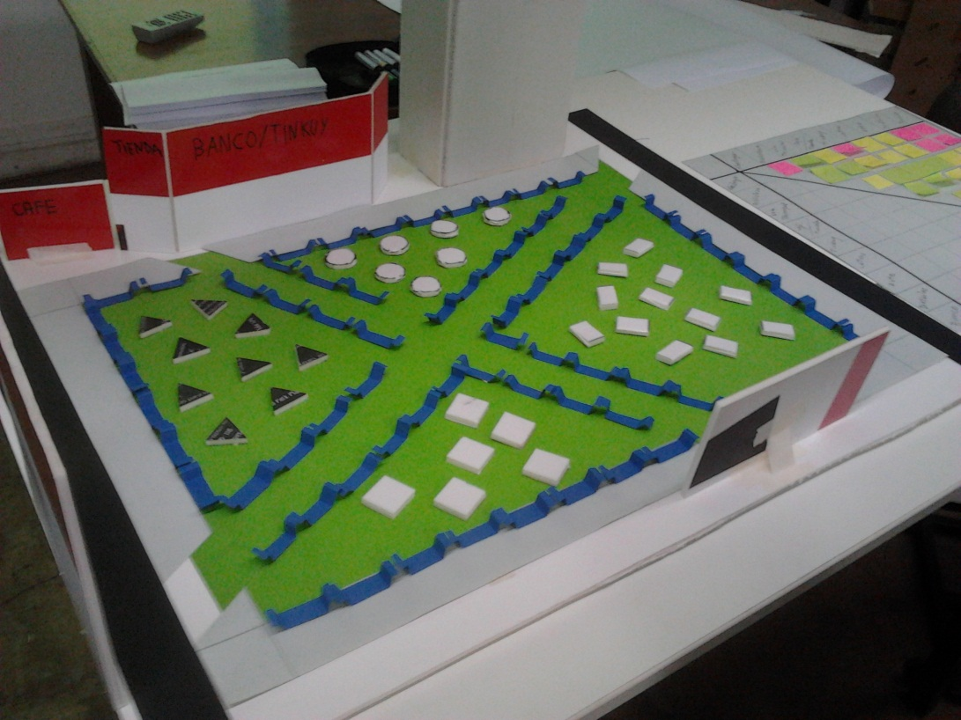

6

|  |  |
| --- | --- |
|  |  |
|  |  |
|  |  |
|  |  |
|  |  |
|  |  |



5

4

3

1

2

|  |  |
| --- | --- |
| 1 | Setting x |
| 2 | Mc Gregor Complex |
| 3 | Library |
| 4 | Coffee |
| 5 | Gift Shop/ Bank/ Tinkuy entrance |
| 6 | Dinthilac Complex |

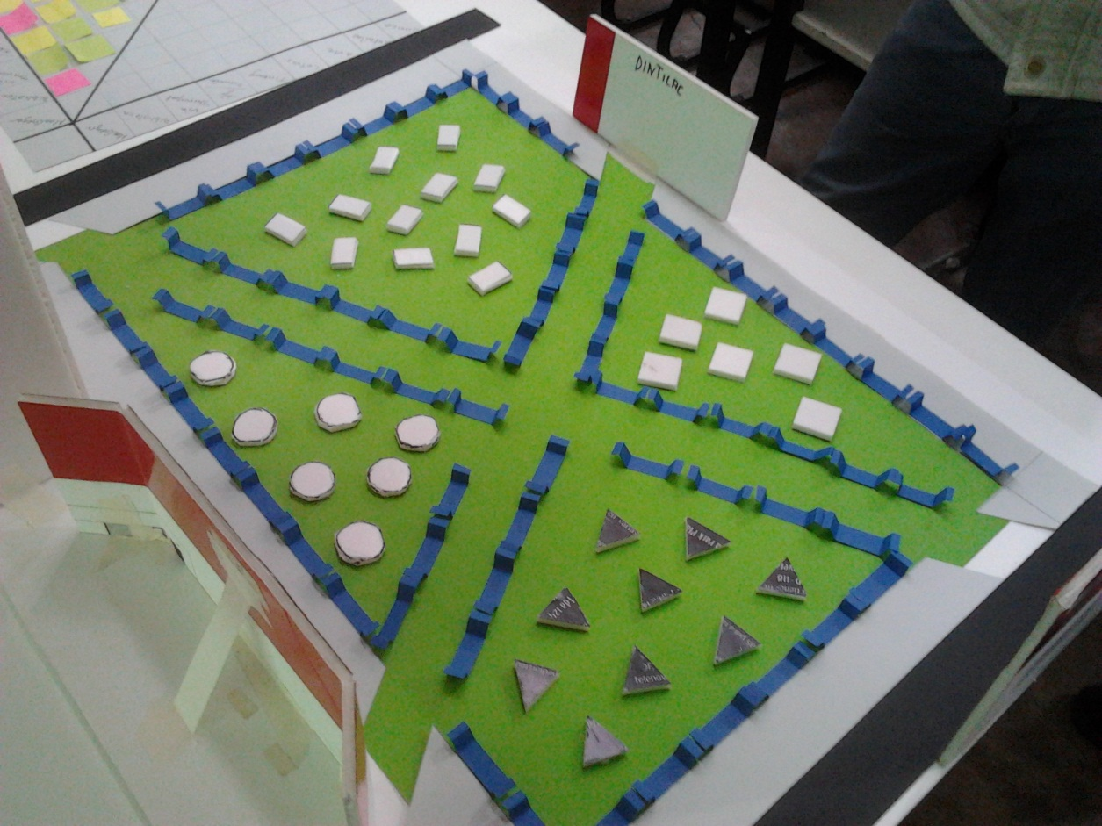

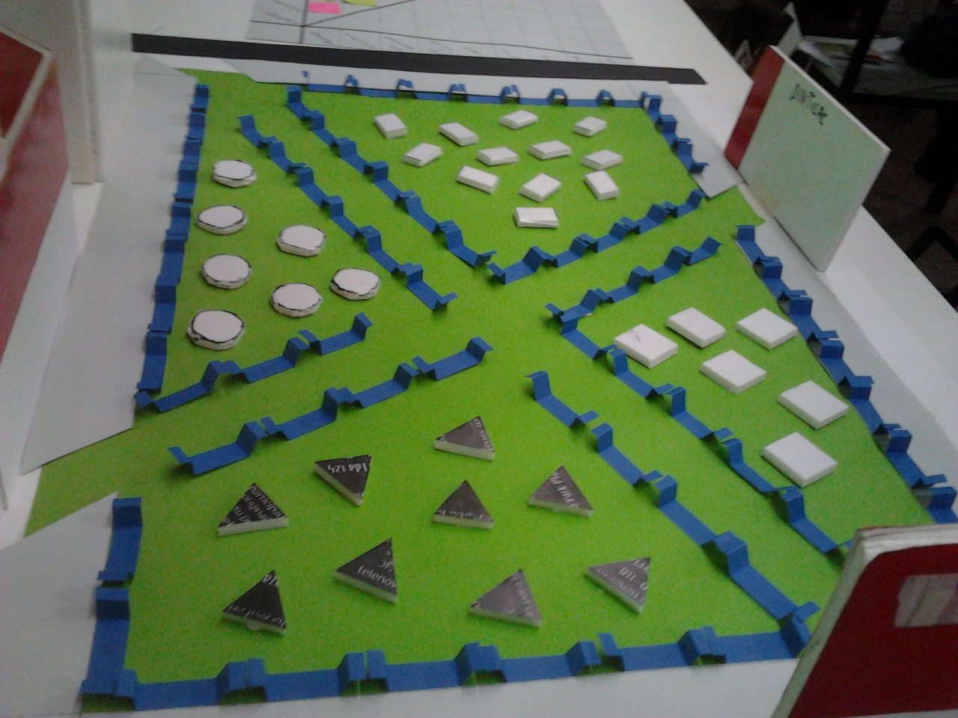

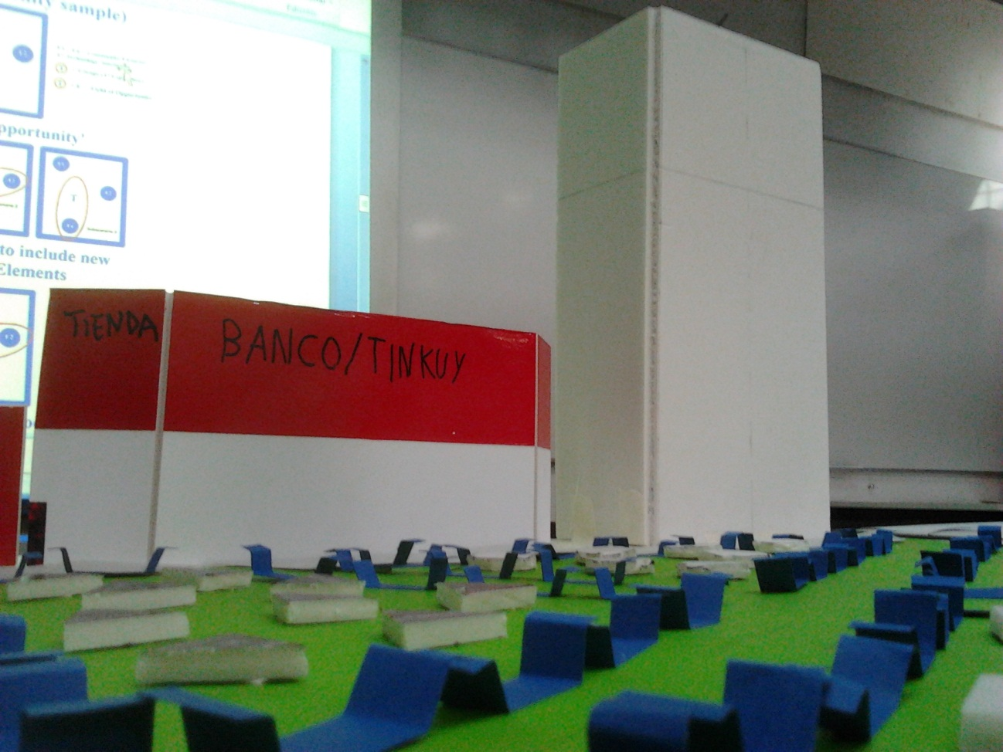

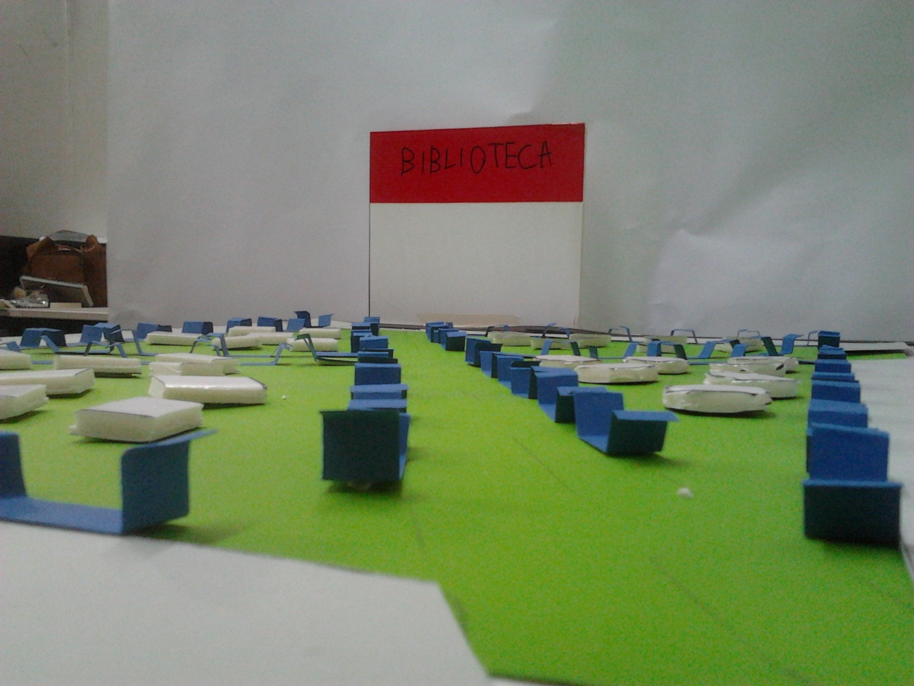

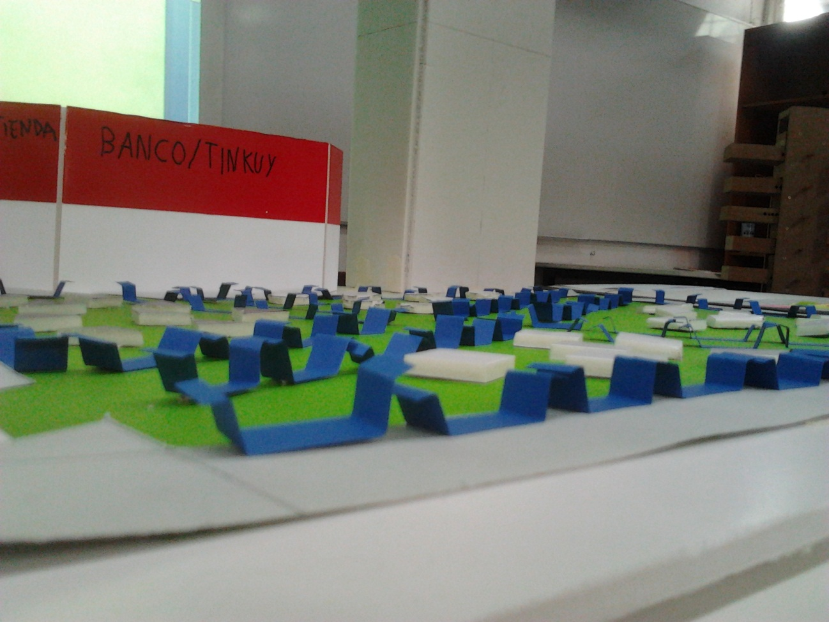

**-Constructing Main Scenario.**

A coupleof students fromthe School of Letters, is going to Tinkuy for coffee and maybe eat something, once they buywhat they want toeat, find no placeinthe buildingthengo out to finda place to eat.

Once they leavethe buildingare directedto the newpark"dynamicway"in whicha large number ofseatsto enjoytheir food andmeet otherclassmates.

**-Designing concept in main scenario**

According to the possible scenario we posed above, we have several possibilities to solve it through the mobiles gardens.  
  
could try to create rest areas where people can meet, but there is no assurance that there is a face to face  
  
could also try cross paths so people would know, but the same people in difference could also earn  
  
that is why our idea had to find a factor incentive face to face contact between students. this is whyconsideringthe twoprevious proposalsincludedecidedto create adepartmentresponsible for the administration, with volunteerswhowant tosupport theidea,then itcouldcreate quizzesto change patternsororder themperiodicallyto different schools. alsocreatea programin which twopeople from differentacademic unitsto commit totake care ofa plant, that promote the integrationbetween people

**Survey results**

Todoa feasibility study, we went to surveystudentsofdifferentracesin Julywhichcould give usyouropinion aboutthe projectand maybesuggestsome aspectwe couldtakeinto account.

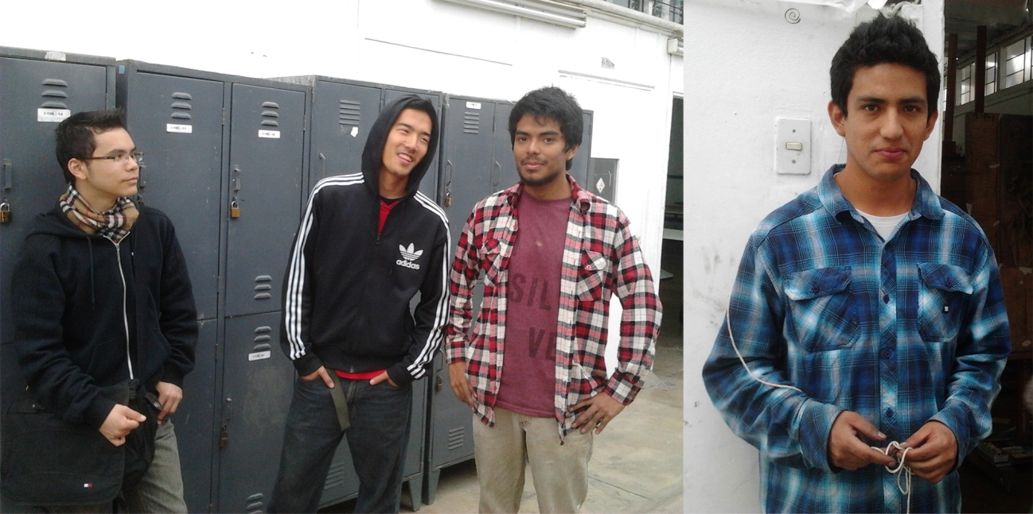

In the summaryof the surveywefoundthatmostpeople are interested inthe idea thatthe patternschangeperiodically, in addition also it interesting thatthere aremorerecreational areas.  
  
Whenwe speakofplantsadoption program, were quitesurprisedbecausethey hadneverthought aboutthe factthata plantcouldgeneratecaringinterpersonalrelationships, thiscertainlywasnuaspect thatcaught my attention, as never beforedonesomething like thatin college. Iswhy it wasa verywell acceptedby respondents

**Suggested Patterns**

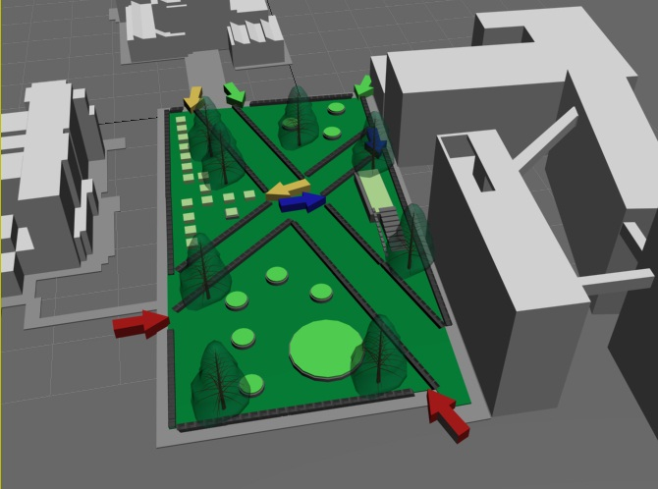

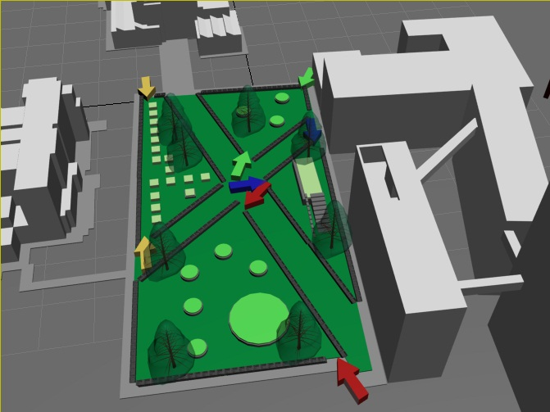

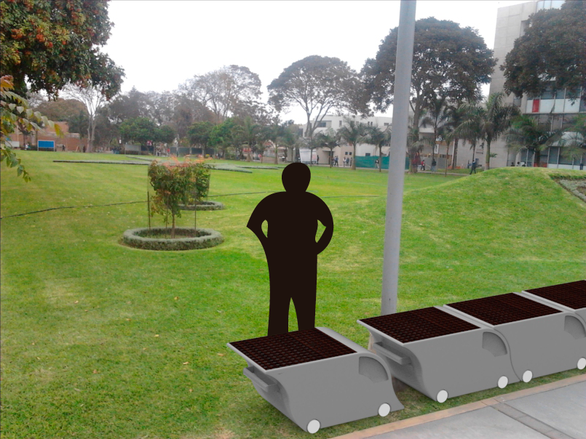

**Design proposals**



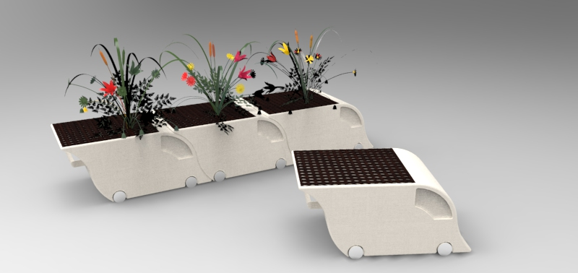

**The plant pot like a modular element can be fabricated in different materials**

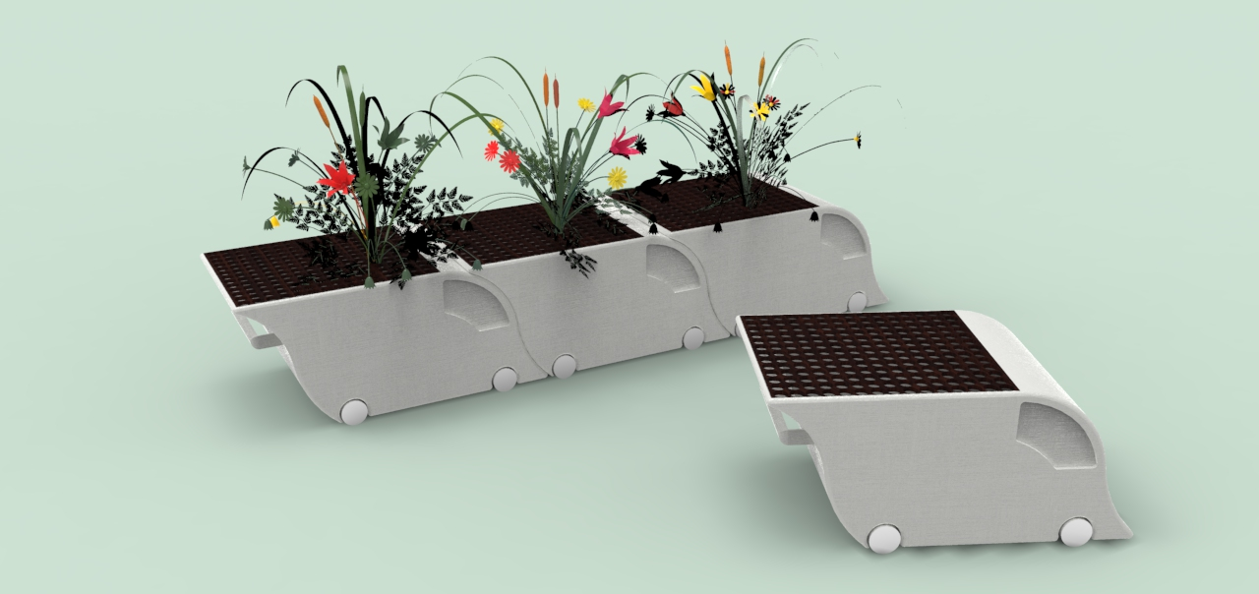

**Concrete and wood**

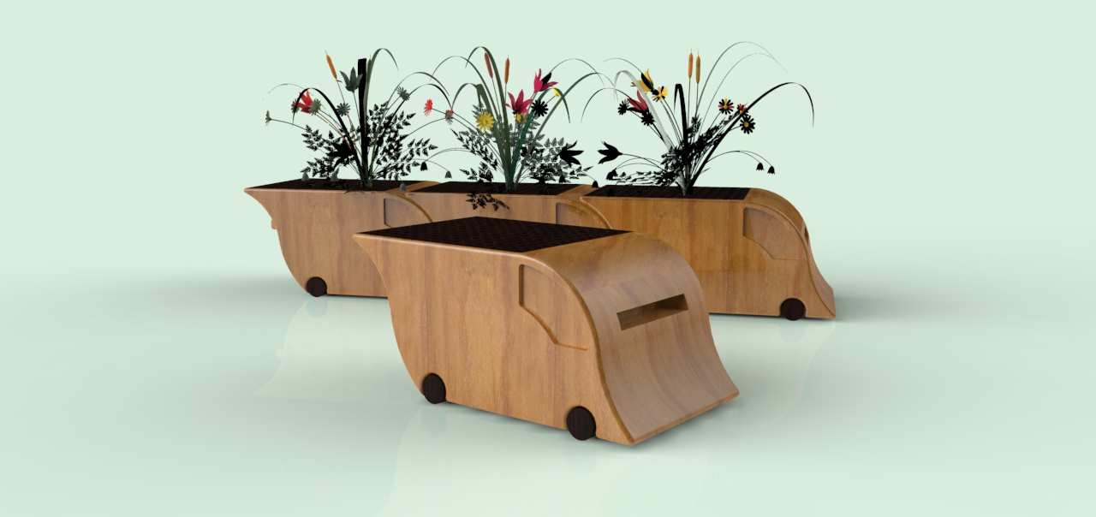

**Wood**

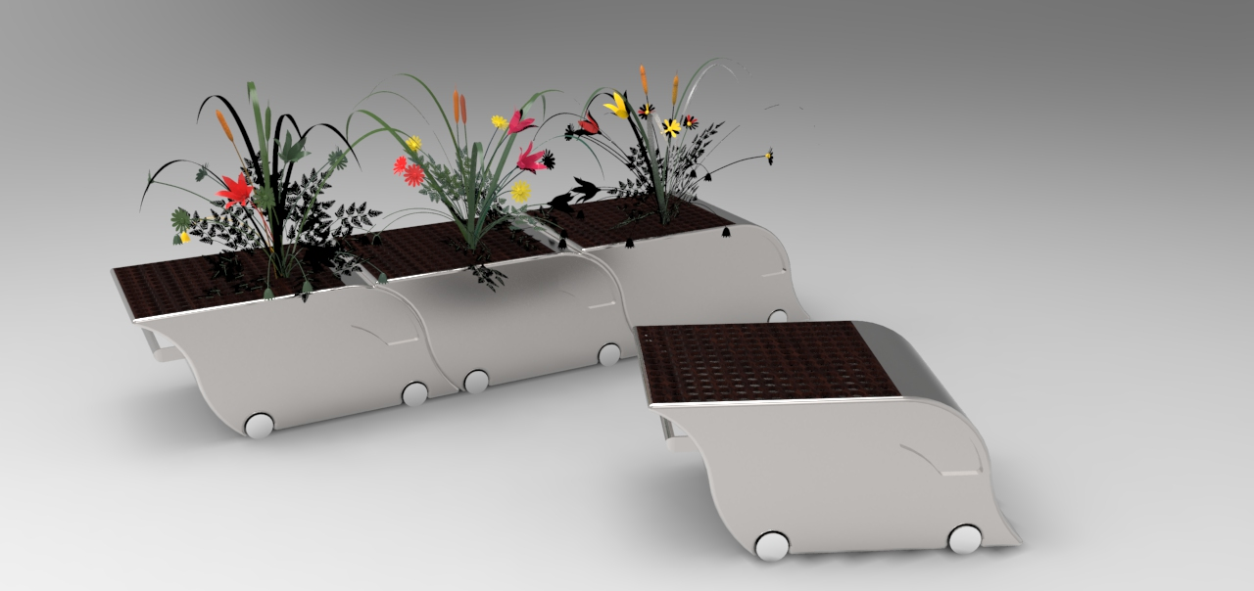

**Steel and wood**

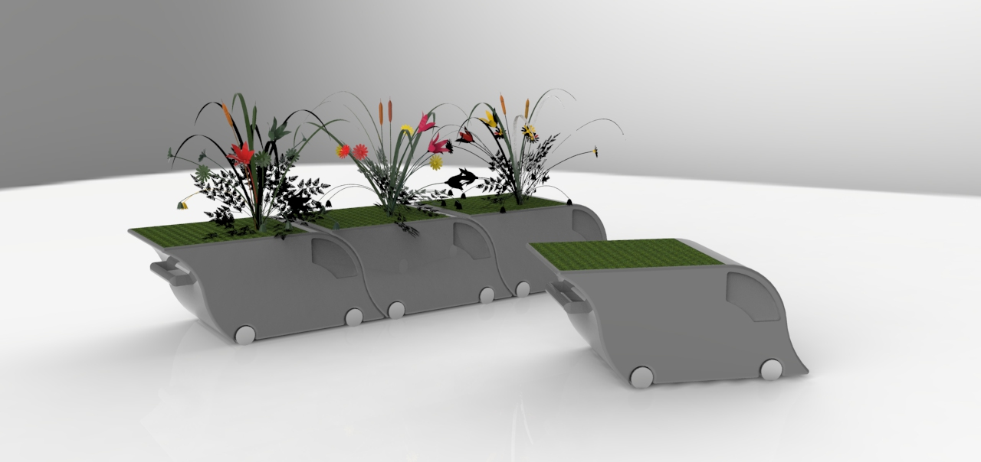

**Concrete**

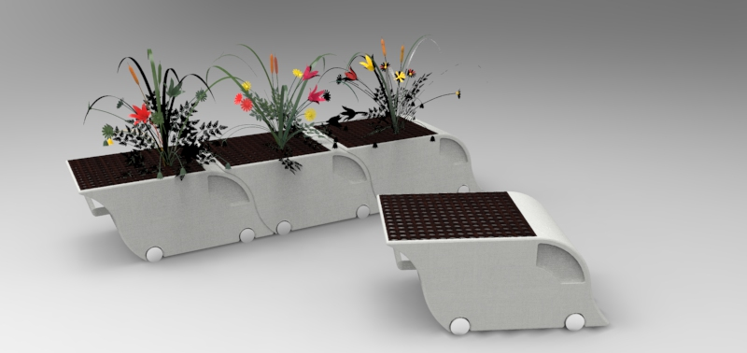

**Cement and wood**

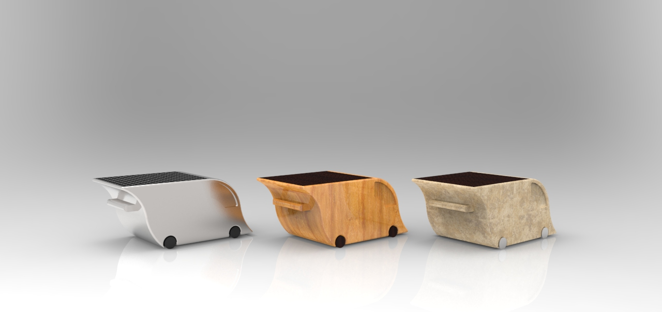

**Pots also have a handle that serves as a connector between them and shaped wheels with two cylinders for a better bearing.**

The plant pot has an sticker or symbol of the PUCP and a number to has an identification when is given to students



|  |  |  |  |  |  |  |  |  |  |  |
| --- | --- | --- | --- | --- | --- | --- | --- | --- | --- | --- |
|  | McGregor | Library | Principal Av. | | Coffee/Shop | Tinkuy | Faculty of letters | Faculty of Art | Dinthilac Complex | Bank |
| McGregor |  |  |  |  | |  |  |  |  |  |
| Library |  |  |  |  | |  |  |  |  |  |
| Principal Av. |  |  |  |  | |  |  |  |  |  |
| Coffee/Shop |  |  |  |  | |  |  |  |  |  |
| Tinkuy |  |  |  |  | |  |  |  |  |  |
| Faculty of letters |  |  |  |  | |  |  |  |  |  |
| Faculty of Art |  |  |  |  | |  |  |  |  |  |
| Dinthilac Complex |  |  |  |  | |  |  |  |  |  |
| Bank |  |  |  |  | |  |  |  |  |  |