ANNEX I

Article 258
If the Commission considers that a Member State has failed to fulfil an obligation under the Treaties, it shall deliver a reasoned opinion on the matter after giving the State concerned the opportunity to submit its observations.
If the State concerned does not comply with the opinion within the period laid down by the Commission, the latter may bring the matter before the Court of Justice of the European Union.

Article 259
A Member State which considers that another Member State has failed to fulfil an obligation under the Treaties may bring the matter before the Court of Justice of the European Union.
Before a Member State brings an action against another Member State for an alleged infringement of an obligation under the Treaties, it shall bring the matter before the Commission.
The Commission shall deliver a reasoned opinion after each of the States concerned has been given the opportunity to submit its own case and its observations on the other party’s case both orally and in writing.
If the Commission has not delivered an opinion within three months of the date on which the matter was brought before it, the absence of such opinion shall not prevent the matter from being brought before the Court.
Article 263
The Court of Justice of the European Union shall review the legality of legislative acts, of acts of the Council, of the Commission and of the European Central Bank, other than recommendations and opinions, and of acts of the European Parliament and of the European Council intended to produce legal effects vis-à-vis third parties. It shall also review the legality of acts of bodies, offices or agencies of the Union intended to produce legal effects vis-à-vis third parties.
Article 265
Should the European Parliament, the European Council, the Council, the Commission or the European Central Bank, in infringement of the Treaties, fail to act, the Member States and the other institutions of the Union may bring an action before the Court of Justice of the European Union to have the infringement established. This Article shall apply, under the same conditions, to bodies, offices and agencies of the Union which fail to act.
Article 267
The Court of Justice of the European Union shall have jurisdiction to give preliminary rulings concerning:
(a) the interpretation of the Treaties;
(b) the validity and interpretation of acts of the institutions, bodies, offices or agencies of the Union;
Where such a question is raised before any court or tribunal of a Member State, that court or tribunal may, if it considers that a decision on the question is necessary to enable it to give judgment, request the Court to give a ruling thereon.
Where any such question is raised in a case pending before a court or tribunal of a Member State against whose decisions there is no judicial remedy under national law, that court or tribunal shall bring the matter before the Court.
If such a question is raised in a case pending before a court or tribunal of a Member State with regard to a person in custody, the Court of Justice of the European Union shall act with the minimum of delay.

ANNEX II

OPINION OF ADVOCATE-GENERAL YVES BOT

6 March 2012

Case C-364/10

Hungary
v
Slovak Republic

I – Factual and legal background to the action

1. […]

2. The facts underlying the dispute between Hungary and the Slovak Republic can be summarised as follows.

3. On the invitation of an association based in Slovakia, the President of Hungary, Mr Sólyom, had planned to go to the town of Komárno (Slovakia) on 21 August 2009 to take part in the ceremony inaugurating a statute of Saint Stephen of Hungary.

4. To understand the circumstances of this visit, it should be noted, in particular, that, first, 20 August is a national holiday in Hungary, commemorating Saint Stephen, the founder and first king of the Hungarian State. Secondly, 21 August is a sensitive date in Slovakia, since 21 August 1968 was the date on which the Warsaw Pact troops, which included Hungarian troops, invaded Czechoslovakia.

5. After several diplomatic exchanges between the embassies of the two Member States regarding President Sólyom’s planned visit, the three highest representatives of the Slovak Republic, namely, the President of the Republic, Mr Gašparovič, the Prime Minister, Mr Fico, and the President of the Parliament, Mr Paška, adopted a joint declaration in which they indicated that President Sólyom’s visit was considered inappropriate, having regard in particular to the fact that he had not expressed any desire to meet Slovak dignitaries and that the date of 21 August was particularly sensitive.

6. Following further diplomatic contact, President Sólyom stated that he wished the visit to go ahead.

7. By note verbale of 21 August 2009, the Ministry of Foreign Affairs of the Slovak Republic informed the Ambassador of Hungary in Bratislava (Slovakia) that the Slovak authorities had decided to refuse President Sólyom entry into the territory of the Slovak Republic on that date for security reasons, on the basis of Directive 2004/38 and of provisions of domestic law on the stay of foreign nationals and on the national police.

8. President Sólyom was informed of the terms of that note while en route to Slovakia; he acknowledged receipt at the border and refrained from entering Slovak territory.

9. By note of 24 August 2009, the Hungarian authorities argued, in particular, that Directive 2004/38 could not form a valid legal basis justifying the refusal of the Slovak Republic to allow President Sólyom to enter its territory. They also found that insufficient reasons were given for the decision to refuse access. For those reasons, they considered that the Slovak Republic had adopted that measure in breach of EU law.

10. At a meeting held on 10 September 2009 in Szécsény (Hungary) the Hungarian and Slovak Prime Ministers adopted a joint declaration maintaining their respective positions regarding the legal aspects of the contested decision, while regretting the circumstances of President Sólyom’s trip. On that same occasion a memorandum was adopted to clarify certain practical arrangements for future official and unofficial visits to the two countries.

11. By a note of 17 September 2009, the Slovak authorities answered the note of 24 August 2009, stating that, in view of the circumstances of the incident, the application of Directive 2004/38 was the ‘last chance’ to stop President Sólyom entering the territory of the Slovak Republic, and that they had not acted in any way contrary to EU law.

12. Meanwhile, on 3 September 2009 the Hungarian Minister for Foreign Affairs sent a letter to Mr Barrot, Vice-President of the European Commission, seeking the Commission’s opinion on the possible breach of EU law by the Slovak Republic.

13. In his reply dated 10 September 2009, Mr Barrot acknowledged that, in accordance with Directive 2004/38, any restriction of freedom of movement must observe the principle of proportionality, that, under Article 27(2) of that directive, it must be based on the personal conduct of the individual concerned, and that the person concerned must be notified, in the manner prescribed in Article 30 of that directive, of that restriction and given a full, precise explanation of the reasons. He also considered that it was for the national courts in the first place to consider whether the rules of Directive 2004/38 had been properly applied. He emphasised that everything possible must be put in hand in order to avoid any repetition of such situations and stated that he was confident that a constructive bilateral dialogue between the two Member States could resolve the dispute.

14. […]

15. […]

16. On 16 December 2009, the Slovak Minister for Foreign Affairs commented on the position adopted by the Commission, stating that ‘from the point of view of the [Slovak Republic], that means that we are right, that when we do something we are acting after proper consideration and we do not complain to the entire world that someone is infringing European rules without knowing what we are talking about’. He stressed that ‘it would be a good thing if Hungary, like us and the Commission … were to consider this matter closed’. He then added that Bratislava had the letter from the Commission as confirmation that his position was correct.

17. […]

18. […]

19. […]

20. On 8 July 2010 Hungary brought this action. The Slovak Republic contends that the Court should dismiss the action and order Hungary to pay the costs.

21. […]

22. […]

II – The main arguments of the parties

[…]

III – Assessment

47. First, I would point out that, in my opinion, the Court certainly has jurisdiction to hear and determine this action […], inasmuch as the dispute between Hungary and the Slovak Republic is indeed based on an alleged infringement of EU law. The Court is requested, in this action, to determine the full significance of the rules on citizenship of the Union and, in particular, to decide whether the Head of State of a Member State may be regarded as a citizen of the Union in his public movements in other Member States. It is in accordance with Article 344 TFEU that the dispute on the interpretation and application of the Treaty on the Functioning of the European Union concerning citizenship of the Union should be settled by the Court by means of one of the procedures provided for in that Treaty, […].

48. With regard to the substance, I would at the start point out that, having regard to the objective circumstances of Mr Sólyom’s proposed visit, as indicated by the observations submitted to the Commission, that visit must be classed as being public in nature. It is common ground that Mr Sólyom intended to go to the town of Komárno in order to attend the inauguration of a symbolic monument linked to the history of the Hungarian State, and that he was to give a speech on that occasion. There is, therefore, no question here of a purely private visit, or even of a visit made incognito, since the Slovak authorities had been notified several times of this visit through diplomatic channels.

49. Consequently, it was indeed in the performance of his duties as the President of Hungary, and not simply as a citizen of the Union, that Mr Sólyom wished to visit the town of Komárno.

50. While the movement of citizens of the Union between Member States is governed by EU law, and in particular by Article 21 TFEU and Directive 2004/38, the same does not apply to visits to Member States by Heads of State.

51. As stated in Article 5(2) TEU, ‘[u]nder the principle of conferral, the Union shall act only within the limits of the competences conferred upon it by the Member States in the Treaties to attain the objectives set out therein. Competences not conferred upon the Union in the Treaties remain with the Member States’. The Treaties being silent on the question of access for Heads of State to the territory of Member States, I conclude that this is a competence reserved for the Member States.

52. Moreover, I note that, in its judgment in Commission v Belgium the Court pointed out, in connection with the 1961 Vienna Convention, that it ‘is a public international law convention concluded by the Member States and non-Member States acting in the exercise of their powers as regards diplomatic relations’ and that ‘in principle it concerns bilateral relations between States’. Consequently, the sphere of diplomatic relations remains within the purview of the Member States, in accordance with international law. In my opinion, the same applies in regard to travel by the heads of State of Member States, including their entry into the territory of other Member States, in circumstances such as those in question here.

53. I do not agree with the idea put forward by Hungary that the status of citizen of the Union and the resulting rights and obligations should prevail over the status enjoyed by Heads of State of the Member States, so that the latter must always enjoy freedom of movement within the Union. Such an extensive interpretation of what is meant by citizenship of the Union would ultimately extend the competences of the Union in a manner incompatible with the principle of the conferral of competences.

54. Moreover, that is a view that ignores the specific character of the position of Heads of State, which lies essentially in their capacity as the supreme organ of the State, representing, personifying and committing the State at international level. In other words, that special position implies that, when a Head of State travels on a public visit, he can never do so on an entirely personal basis in so far as it is primarily the community he represents that is welcomed by the State receiving him.

55. While there is at present no international convention intended to give a general definition of the status of Heads of State in international law, and in particular the question of their entry into State territory, the fact nevertheless remains that, under international law, Heads of State undeniably enjoy a position that cannot be compared to any other, and certainly not to that of a citizen wishing to make a purely private visit to another State.

56. The special treatment afforded by international law to Heads of State is derived largely from international custom and, to a lesser extent, concerning certain particular aspects, from international conventions. That special treatment concerns the protection, facilities, privileges and immunity accorded them.

57. In my view, the status of the highest representative of the State, which is that of Head of State, and the principle of the sovereign equality of States militate in favour of the opposite proposition to that supported by Hungary, namely, that visits by Heads of State within the Member States of the Union depend on the consent of the host State and the detailed conditions defined by the latter within the framework of its competence, and cannot be understood in terms of freedom of movement.

58. That said, as in the case of any competence reserved for them, the Member States should not exercise their diplomatic competence in a manner that might lead to a lasting break in diplomatic relations between two Member States. Such a break would, in fact, be incompatible with the integration process aimed at creating, in the words of the preamble to the EU Treaty, ‘an ever closer union among the peoples of Europe’ and would constitute a barrier to the attainment of the essential objectives of the Union, including the aim of promoting peace.

59. Only a situation of persistent paralysis in diplomatic relations between two Member States, contrary to their commitment to maintain good-neighbourly relations consubstantial with their decision to join the Union, would be covered by EU law, if only because, in accordance with the last paragraph of Article 4(3) TEU, Member States must refrain from any measure that could jeopardise the attainment of the Union’s objectives.

60. We are obviously not dealing with such a situation here, as is evident, for instance, from the meeting between the Hungarian and Slovak Prime Ministers on 10 September 2009, that is to say, a few days after the incident giving rise to the present proceedings. On that occasion, they also reiterated their commitment to respecting and applying all the articles of the Treaty on Good-neighbourly Relations and Friendly Cooperation between Hungary and the Slovak Republic, signed in Paris on 19 March 1995.

61. EU law not, therefore, being intended to govern the incident occurring on 21 August 2009, I consider that there can be no finding of an infringement [the] TFEU.

62. Examination of the complaint that the Slovak Republic committed an abuse of rights by relying, in particular, on Directive 2004/38 in its note verbale of 21 August 2009 in order to refuse to allow President Sólyom access to its territory cannot, in my view, alter that conclusion.

63. The position of the Slovak Republic is consistent on that point. It acknowledges that the reference to Directive 2004/38 in that note verbale was inappropriate, with which I can only agree, in view of the foregoing considerations. Nevertheless, I cannot deduce that this constitutes an abuse of rights within the meaning of the case-law of the Court, which requires the presence of both an objective and a subjective element.

64. It is evident from the observations submitted to the Court that, for the Slovak Republic, after a number of attempts through diplomatic channels to express its disapproval of Mr Sólyom’s proposed visit on a date that Member State regarded as sensitive, this note verbale was the last resort. It seems that considerations concerning public security gave rise to the reference to Directive 2004/38 in that note. In so far as such considerations are mentioned in that directive, in particular in the first subparagraph of Article 27(2), and as Mr Sólyom’s proposed visit could reasonably, having regard to the political context of that visit, prompt an assessment of public security risks, it does not seem to me to be proved that, in referring to Directive 2004/38 in the note verbale of 21 August 2009, the Slovak Republic committed an abuse of rights.

65. Finally, in response to the last complaint made by Hungary, I would say that, inasmuch as the present dispute concerns only the visit of a Head of State, there is no need, in the present proceedings, to examine further what the position of citizens of the Union performing other official duties would be.

IV – Conclusion

66. In the light of the foregoing considerations I propose that the Court should:
–
dismiss the application;
–
order Hungary to pay the costs.

ANNEX III
Commission Decision
of 28 November 2007
concerning the WRAP Printing and Writing Paper Scheme notified by the United Kingdom

THE COMMISSION OF THE EUROPEAN UNION,
Having regard to the [Treaty on the functioning of the European Union], and in particular the first subparagraph of Article [108 (2)] thereof,
Having regard to the Agreement on the European Economic Area, and in particular Article 62.1(a) thereof,
Having called on interested parties to submit their comments pursuant to the provision(s) cited above and having regard to their comments,
Whereas:
[…]
2. DESCRIPTION OF THE MEASURE
Granting authority
(3) WRAP is a company established by the Government of the United Kingdom in partnership with other shareholders to promote sustainable waste management, and more specifically to promote efficient markets for recycled materials and products. Its central objective is to enable recycled markets to function more effectively by stimulating demand for recycled materials and products, thereby improving the economics of collection. Although WRAP functions as an adjunct to the Government and implements government policies, it has the form of a private company. WRAP's shareholders comprise several representatives of the industries with some interests in waste management, among them the Confederation of Paper Industries and the Chartered Institute of Waste Management, charities such as Wastewatch, and representatives of the devolved and British governments.
Objectives
(4) The objective of the notified scheme is to increase collection and recycling of printing and writing (P & W) paper from offices and businesses by increasing recycling capacity under the obligation to collect additional waste paper. The United Kingdom expects that the increased recycling capacity, linked to the legal obligation by the beneficiary of the aid to use new additional collections, will lead to a net increase in additional collections of P & W waste paper. […] Currently, most of the paper produced by businesses and offices is not collected and sorted for recycling, due in particular to technical difficulties, low costs of landfill, and price volatility. […]
The tender
(5) WRAP intends to address the objectives by offering grants to paper manufacturers to increase P & W paper reprocessing capacity that utilises mainly waste paper from offices and businesses as its raw material input. The budget for this measure is between GBP 6 million and GBP 20 million, (approximately between EUR 8,6 million and EUR 28,6 million). The budget will cover the period until 31 March 2011. Between two and ten paper producers are expected to benefit from the aid. The aid is financed through the general budget of the Department for Environment, Food and Rural Affairs (DEFRA).
(6) The notified aid is to be granted following a competitive tender process, inspired by EC public procurement procedures.
[…]
6. ASSESSMENT OF THE MEASURE
6.1. Existence of aid under Article [107 (1) TFEU]
(29) Under Article [107 (1) TFEU], "any aid granted by a Member State or through State resources in any form whatsoever which distorts or threatens to distort competition by favouring certain undertakings or the production of certain goods shall, insofar as it affects trade between Member States, be incompatible with the common market."
(30) In this case, the measure will be funded by resources granted by the State under the WRAP programme. The aid will be granted to individual beneficiaries. The competitive selection procedures may ensure that the amount of the subsidy is limited to the minimum, but does not take away the aid character of the measure. The measure distorts or threatens to distort competition, as it may cover a significant part of investment costs, which would allow the beneficiary to charge a lower price for the P & W paper it produces. The measure will affect the market for new paper, but also the market for waste paper, which is valuable commodity in demand by the paper industry. The measure is likely to affect trade between Member States, since both new paper and waste paper are traded internationally. A large amount of the United Kingdom paper consumption is imported mainly from other Member States and the United Kingdom is among the biggest exporters of waste paper.
(31) Therefore, the scheme qualifies as State aid under Article [107 (1) TFEU].
[…]
HAS ADOPTED THIS DECISION:
Article 1
The notified State aid WRAP Printing and Writing Paper Scheme, which the United Kingdom is planning to call for tender, with a budget of a maximum GBP 20 million (approximately EUR 28,6 million) and valid until 31 March 2011 is compatible with Article 87(3)(c) of the EC Treaty.
Implementation of the measure is accordingly authorised.
Article 2
This Decision is addressed to the United Kingdom.

Done at Brussels, 28 November 2007.
For the Commission
Neelie Kroes
ANNEX IV

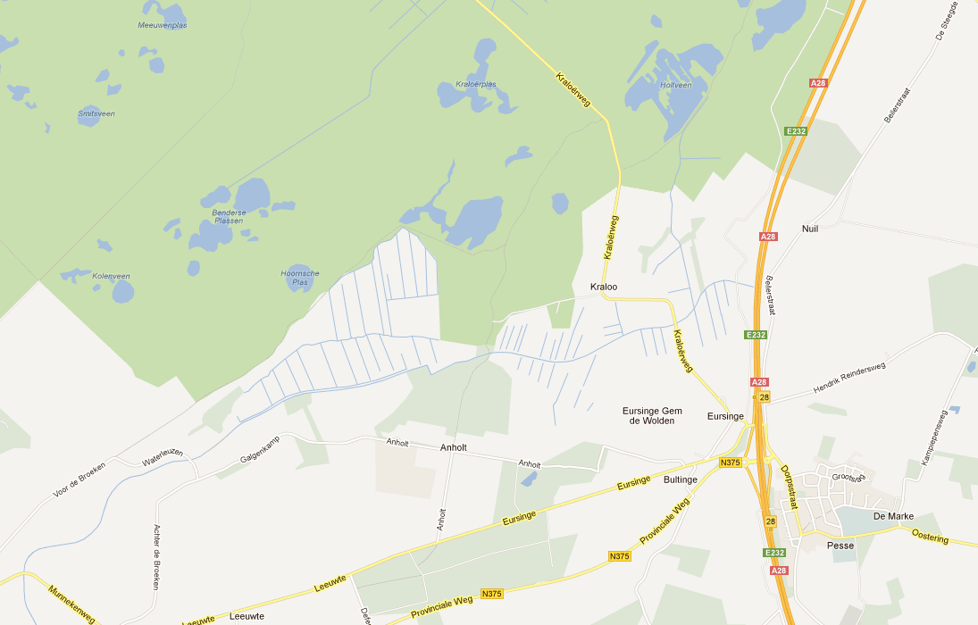
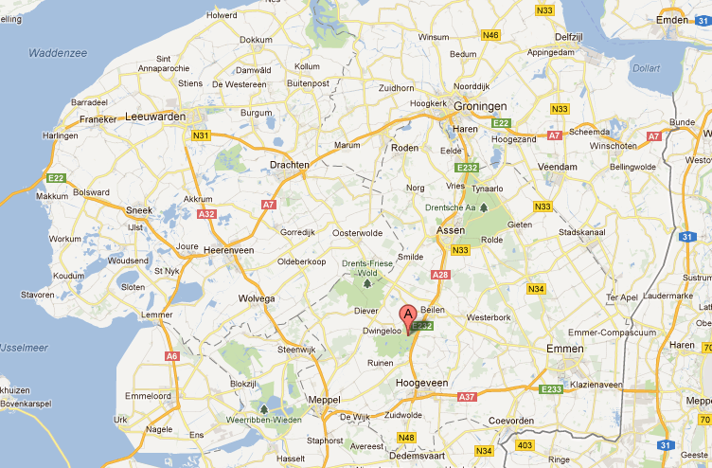

ANNEX V

DIRECTIVE 2009/142/EC OF THE EUROPEAN PARLIAMENT AND OF THE COUNCIL
of 30 November 2009
relating to appliances burning gaseous fuels

THE EUROPEAN PARLIAMENT AND THE COUNCIL OF THE EUROPEAN UNION,

Having regard to the Treaty on the Functioning of the European Union, and in particular Article 114 thereof,
Having regard to the proposal from the Commission,
Having regard to the opinion of the European Economic and Social Committee,
Acting in accordance with the procedure laid down in Article 294 of the Treaty,

Whereas:

(1) Council Directive 90/396/EEC of 29 June 1990 on the approximation of the laws of the Member States relating to appliances burning gaseous fuels has been substantially amended. In the interests of clarity and rationality the said Directive should be codified.
(2) Member States are responsible for ensuring the health and safety on their territory of their people and, where appropriate, of domestic animals and goods in relation to the hazards arising out of the use of appliances burning gaseous fuels.
(3) In certain Member States, mandatory provisions define in particular the safety level required of appliances burning gaseous fuels by specifying design, operating characteristics and inspection procedures. These mandatory provisions do not necessarily lead to different safety levels from one Member State to another but do, by their disparity, hinder trade within the Community.
(4) Different conditions as regards types of gas and supply pressures are in force in the Member States. These conditions are not harmonised because each Member State’s energy supply and distribution situation is peculiar to it.
(5) Community law provides - by way of derogation from one of the fundamental rules of the Community, namely the free movement of goods - that obstacles to movement within the Community resulting from disparities in national legislation relating to the marketing of products must be accepted in so far as such obstacles can be recognised as being necessary to satisfy mandatory requirements. Therefore, the harmonisation of legislation in the present case should be limited to the provisions necessary to satisfy both the mandatory and essential requirements regarding safety, health and energy conservation in relation to gas appliances. These requirements should replace the national provisions in this matter because they are essential requirements.
(6) The maintenance or improvement of the level of safety attained in Member States constitutes one of the essential aims of this Directive and of safety as defined by the essential requirements.
[…]

