by

Aída Limón Bustamante
Tania Gutiérrez Sáez

Social Cohesion Design Workshop 24 – 29 September 2012 at PUCP, Lima, Peru

Realized by the Industrial Design Faculty’s coordinator Eduardo Ajitofrom PUCP and the Social Cohesion Design Foundation, Delft, Holland represented by Clemens de Lange for the Grijsen Company, Winterswijk, Holland

INDEX
Grijsen Park &straatdesign company analysis
Group introduction
- Team members &foto
- Introduction
- Motivation & expectations
- Logo &housestyle
Project description
Social cohesion deign mission
Identification I1
- Setting selection
- Elements & events
- 3d scenario board
- SubScenarios
Integration I2
- Selection of the best subscenario combinations applying A Sub Matrix tool.
- Main Scenario construction
- Designing concept in main scenario
Implatation I3
- Develop the "Look & Fell₺ of the project in order to communicate the social MISSION trough the name & an advertisement slogan
- 3D design in main PUCP garden setting
- Plan for Test – Pilot (finance, stakeholders involvement)
Conclusion

GRIJSEN PARK & STRAATDESIGN COMPANY
HISTORY
When Grijsen became a company in 1989, they were dedicated to producing standard street furniture to furnish the parks. In 1996 Grijsen with the help of designer Eric Kruisselbrink developed for the community Leiden a whole new litter bins idea: the Constructo. Cities like Amsterdam were soon discovering the benefits of these litter bins.
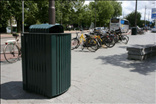
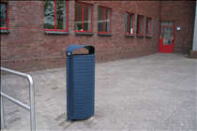

TECHNOLOGY / MATERIALS
Most of Grijsen Company projects are made of wood and steel. They guarantee a Dutch quality product, because the whole production process takes place exclusively in Dutch companies. The forms they work with are not complex, this doesn’t mean they have bad or low technology, actually, to achieve clean and simple products they need to work with good processes and be really retailer and precise in order to get a product with a quality like theirs.
SUSTAINABILITY
It is clear that the company has a very ecofriendly policy using only one material, and not mixing them with each other, making the recycling process much easier. The processes and materials as well don’t contaminate or jeopardize the environment where they are maintained.
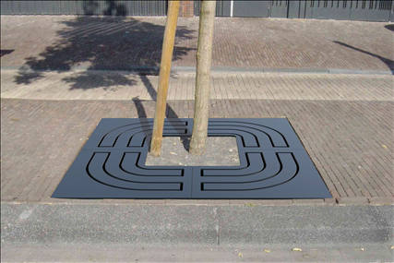
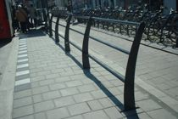

“LOOK & FEEL”
Visually and functionally their designs reflect simplicity, style and comfort, being a very good quality one of the most important aspects of their furniture.
The design concept is very important in the creative process, which formally ends up in simple, honest and clean products with processes that don’t really apply or require high technology. Showcasing the qualities and particularities of the materials seems to be a very important factor in their projects, but this doesn’t come for free: the company is committed to the environment, and being ecofriendly is one of the requirements they never leave behind.

INNOVATION
The company’s idea of developing and concentrating on street furniture’s is great. We live in a big city and street mobile is always needed. Having more furniture like this all over the city will encourage people to go out walking more often

WEBSITE PRESENTATION
I think there’s a lot of work to be done with the website. The projects they present are really interesting and innovative, but the way the site is being displayed doesn’t make people want to know more about it. The colors don’t relate to what they are offering, they are really basic and don’t benefit the furniture advertisement. Using color psychology is important specially if the project has a specific and particular approach.

LOGO
I think that the logo and the company name could graphically relate more to the image the company projects through their own products. The look the logo gives is older and also a little bit more serious that how it actually is.

POTENTIAL IN PERU
I believe that projects like this should be encouraged in our country. We don’t have that much of street furniture in the city, so at first, it will take some time for people to get used to them and also the security issue, because there could be some stealing, so there should be an special anchorage system that doesn’t change the design at all.
Being the designs so simple and clean they would easily adapt to the urban landscape we have in the city.
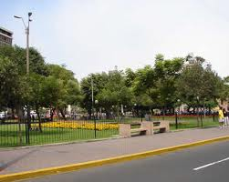
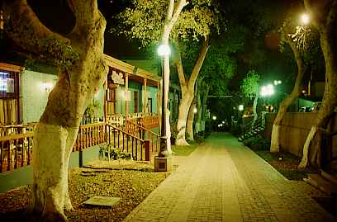

GROUP INTRODUCTION
TEAM MEMBERS AND FOTO
Team members:
- Aída Limón Bustamante (Industrial design)
- Tania Gutiérrez Sáez (Industrial design)
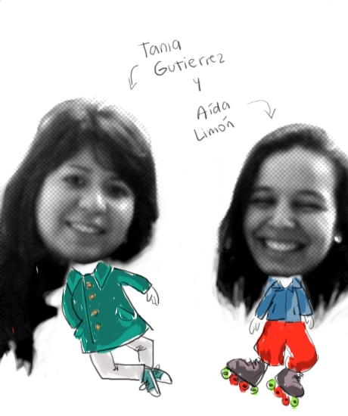

INTRODUCTION
PUCP is characterized by being a very receptive and multicultural university. With more than twelve faculties and over 40 careers, the students coexisting with each other are very different between them, having different interests and preferences; this makes PUCP a very tolerant, diverse and rich place where to study.
Developing a concept and design for a new green area in which people interaction will take part, has to take into consideration lots of aspects for a project like this to function. As designers, people’s needs are one of the most important elements when conceptualizing and mostly in every step of the designing process. In a project like this, that has as final gold achieving social cohesion at the campus, and, as we have already explained, having this many different students, the challenge is on trying to create and space and activities that will make a journalism student interact with an engineering one, and then both of them, on a different level, with PUCP community.

MOTIVATION & EXPECTATIONS
Our main motivation is to bring people together through a beautiful environment, relaxing activities and healthy competition. We understand that nature is nowadays underrated, we have buildings, streets, pavements, etc., all pavement constructions that see nature as a secondary element, finding green areas is more uncommon every day.
Unlike the rest of Lima, PUCP is really concerned on having and maintaining green areas inside the campus. In that sense, developing a project with this goal at a university like ours seems to be a good idea that could last in time.
Our expectations is for PUCP community members, to actively participate from this activities, to see this place as a fun and relaxing area in which they can work with flowers and have beautiful results. This kind of project works really well at our university, we believe that we can incentive other places in Lima to take the same idea and adapt it to their infrastructure.

LOGO & HOUSESTYLE
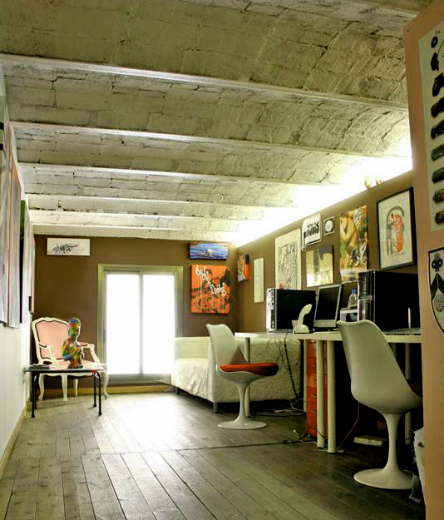

PROYECT DESCRIPTION
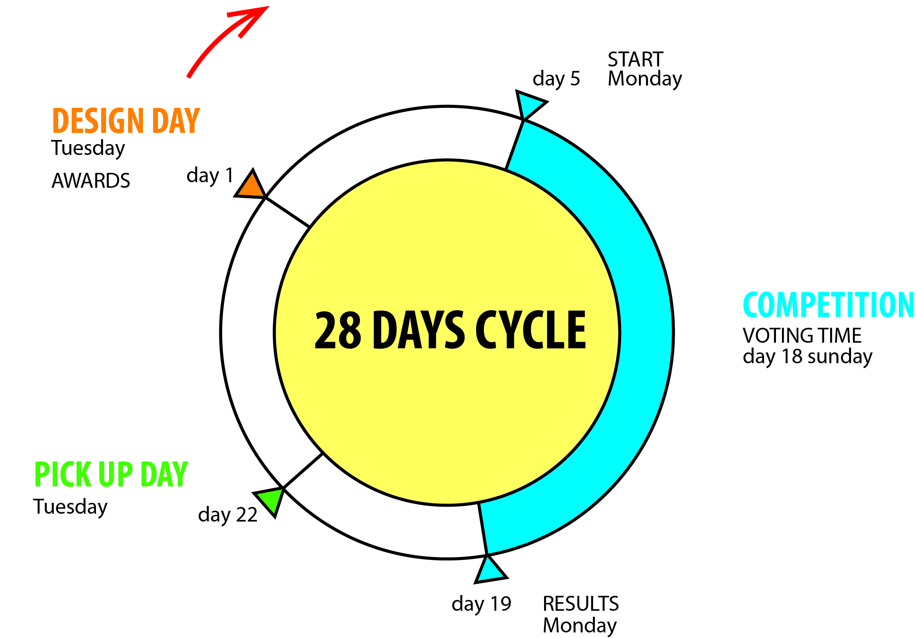
Linia’s project gold is to make interactions between people that don’t know each other. It takes part on one of the largest green areas of the campus; here students will work in teams one day amonthto create flower arrangements"design day₺, here they’ll have the chance to choose their own flowers, plants and pots to do this.
For the rest of the month the arrangements will be displayed all around the campus for people to look at them; there will be a "pick up day" in which PUCP members could go and grab the flowers they most like, this will happen before "design day₺, so the flowerpots will be empty and people will be happy taking the flowers home.
After design day and for the rest of the moth, the big flowerpots where we put the plans, flowers and accessories to make the arrangements, will become a place in which PUCP community members can go and sit on a relaxing, full of nature environment. Contest will be held, the prize will be the exhibition of the arrangement until it dies (exonerated from pick up day) and a picture of the arrangement on Q supplement.
.
Thursday
SOCIAL COHESION DESIGN MISSION
PUCP members, as we have explained, have different activities, interest and preferences. By creating a relaxing environment, surrounded by beautiful plants and having healthy competition activities, we are bringing them together and providing them a space they will immediately relate to a peaceful place. This will give them the opportunity to meet and work with people otherwise they would have never even talked to.

IDENTIDFICATION I1
SETTING SELECTION
The central stage of our project is the main garden of PUCP university. But this scenery grows as the project is ran, because once the pots have been decorated, they are moved to different points at the campus to show what have been done.
Nowadays, the main garden is almost not used. The university community doesn’t interact with it although is a high potential place and almost everybody passes by it once a day.
ELEMENTS
- PuntoEdu
PuntoEdu is the PUCP’s newspapers where you can find different kinds of articles related or not to the university, publications, events and more. It also has a web site. The physical newspaper is given each Monday.
- Students
PUCP University has over 18500 students. There are 10 faculties and 44 careers, meaning that the student’s interests and preferences are really different between each other. They spend most of their time here and do lots of different activities during the day: study, eat, relax, do sports, etc., this might take them to consider PUCP as their second home.

- PUCP workers
PUCP workers are, besides students, one of the most important elements of our university; they include teachers, maintenance people, PUCP administrators, cafeteria workers, etc. They spend most of their time here at the university and, like most of the students, consider this their second home.
EVENTS
- Design day
This day will take part once a month and is the central event of the project. Students and the rest of the PUCP community members will go to the main garden and participate from the flower arrangement activities. They’ll have about 3 hours to produce the best arrangement they can by using the flowers and pots given to them.

- Competition
It starts 2 days after the Design day and finishes a week before the next Design day. During this time the designs will be showed around the campus and via an open group in Facebook, people will be able to vote for their favorite design to choose a winner. The results will be given the next Design day and the winner pot will stay at university and a photograph of it will be put on Q supplement
- Exposition
The exposition has two parts: the first one that takes place around the campus during the voting; and the second part is at the main garden where the winner arrangement will be displayed until it dies.
- Pick up day
The Pick-up day is around 28 days after the Design day. The idea of this day is to invite the whole PUCP community to pick up a plant from the already designed pots distributed by the campus in order to take and care them to their houses.

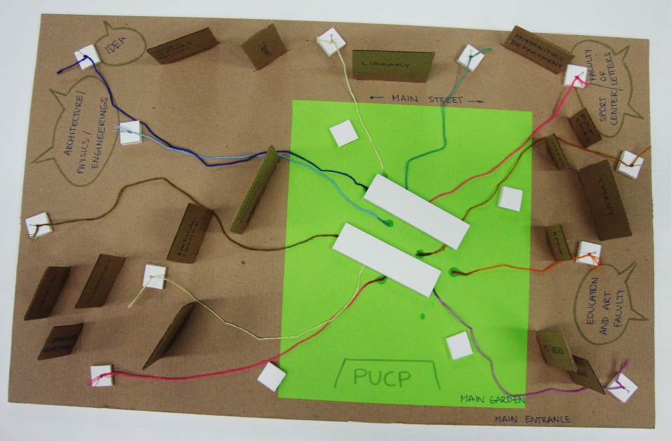
3D SCENARIO BOARD

Our scenario is situated in the university’s central garden. This is surrounded by important buildings and faculties, around this there is always a lot of people, but no one goes and walks across this garden like all of the other ones at the university.
The flowerpots are mobile; we’ve use pins and threads to represent this. At first they are in the main garden and then distributed to other areas in the university, and finally they come back to the main garden to start the cycle again.
The 3d model is made out of: foamboard to represent the small and big flowerpots, and cardboard for the base and the most important buildings around the garden
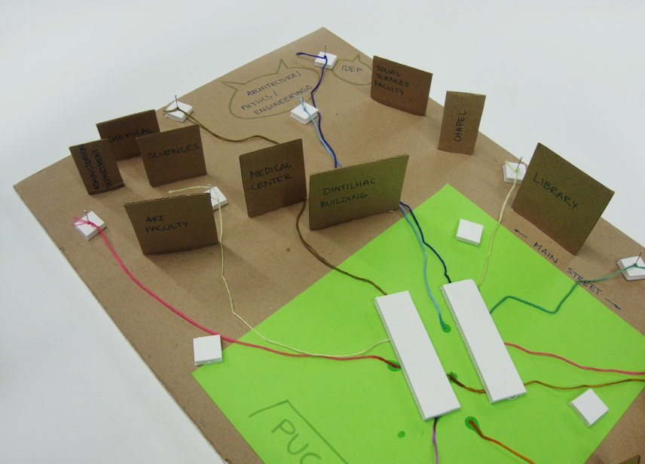

Flower pots go from the main garden to the other areas in the university

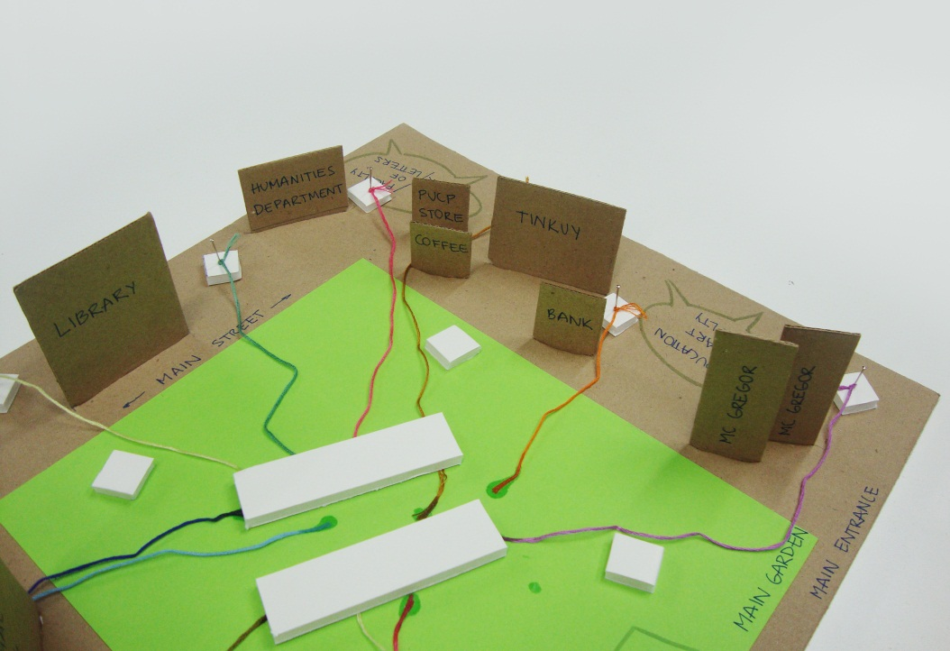

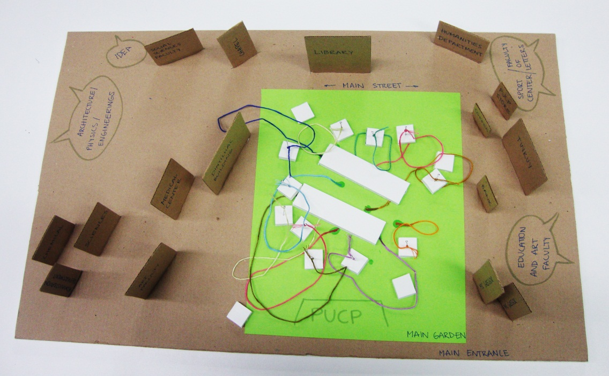

Individual flowerpots for display

Further places in the university

Big flowerpots to put all the plants and flowers

Places surrounding the garden

MAIN SCENARIO CONSTRUCTION
Example history
One Monday Javiera was reading the PuntoEdu and found an article about a new green space at PUCP called that was going to be inaugurated on Thursday, the paper also mentions something about a flower arrangement contest in which you can participate with your friends. Javiera tells Manuel about this, he likes the idea so they talk with some other people from their faculty and convince them to go and participate.
When they arrive on Thursday they see that there are some other groups working there, there are lots of flowers, plants and accessories on a central table, soon they start preparing their arrangement. They have to pick up the plants and flowers they most like, move them from the table to their big pots, etc. For the next 3 days some PUCP workers pick them up and start putting them all around the campus for other students and PUCP community members to look at them. For the next two weeks after this, the facebook voting starts, Javiera aims her classmates to vote for her; suddenly she realizes that has more than 500 votes.
Then, the third Monday after reading about it, the results are ready, Javiera, Manuel and their other friends didn’t win, she wasn’t upset because overall she had a great time. The next Thursday she realizes that people are taking some of the flowers from the pots, so she goes to Manuel and tells him to go together on searching for the flowers they liked, after this they went back to the big flowerpots area and sit where the plants and flowers used to be, after design day and for the rest of the month this place becomes a table and seating place where people can go and relax by being around nature. For the next six days maintenance workers take care about cleaning the pots and bringing them back to the main garden, the next day, the cycle starts again with the awards ceremony and a new arrangement contest.
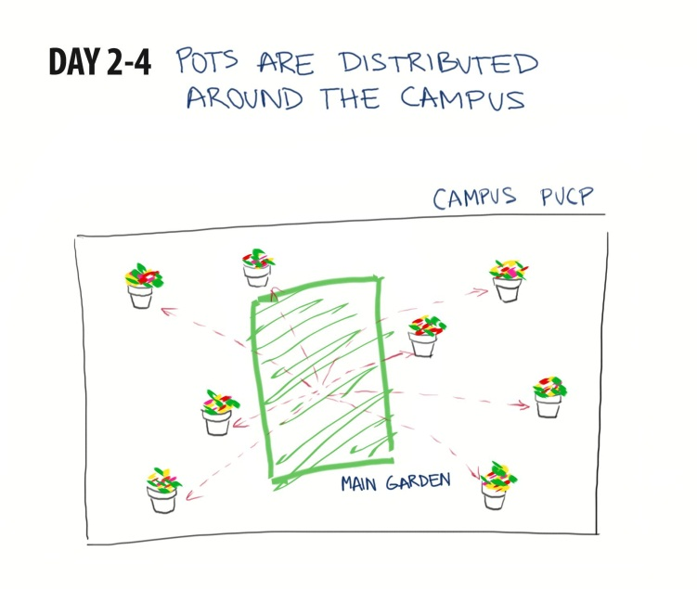
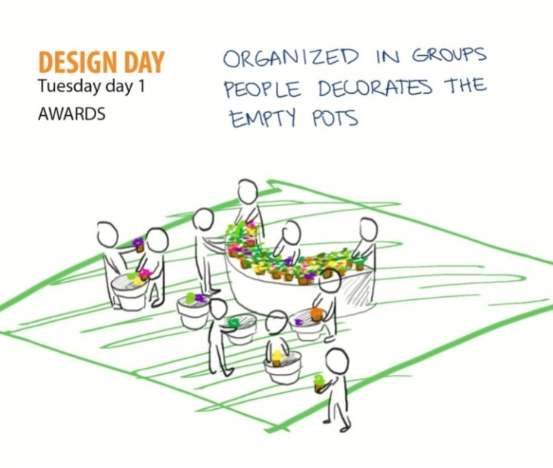

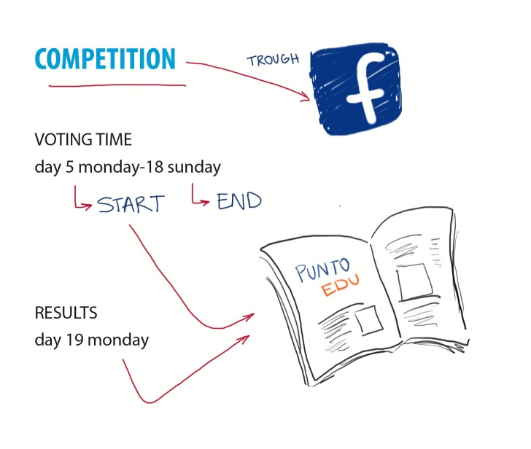
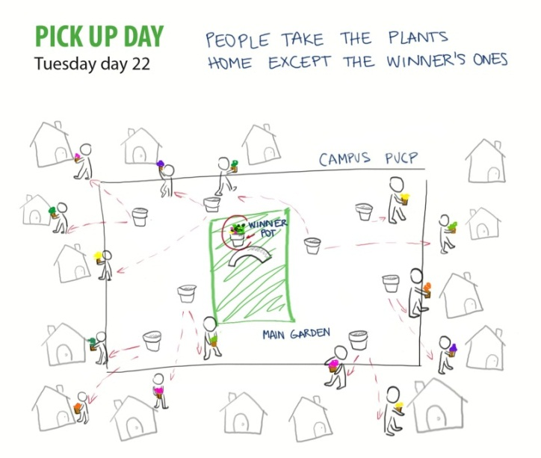
Thursdayday 22

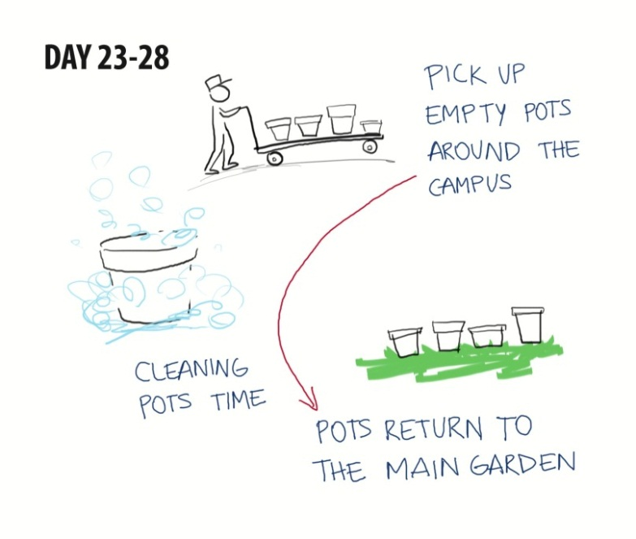

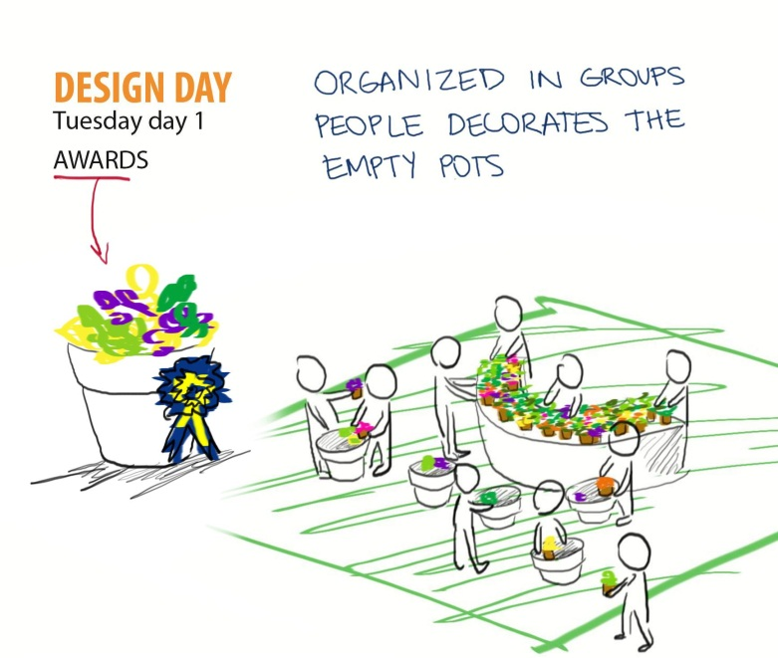

DESIGNING CONCEPT IN MAIN SCENARIO
The area where the gardening activities will be held consists of:
- Two big flowerpots which have a double function: to work as tables during design days, and resting seats and tables for the rest of the month. This is a piece with two levels, in the first case, this is to make easier the display of the flowers and plants, and also to facilitate when trying to reach something that is not that close.

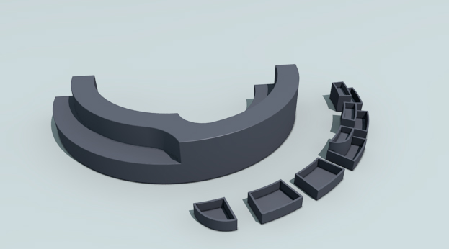

- An space between these two for people to circulate and easily grab the flowers, plants, and other things to make their arrangements
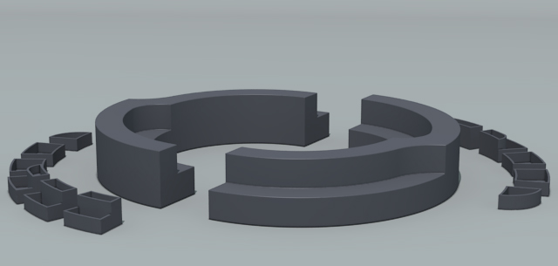

- 12 individual flowerpots that will be distributed around the 2 big ones, so people can see the flowers and plants that are left. With a configuration like this, they can see what the other participants are doing and interact with each other rather than working every team on their own.

IMPLANTATION I3
DEVELOP THE “LOOK & FEEL” OF THE PROJECT IN ORDER TO COMMUNICATE THE SOCIAL

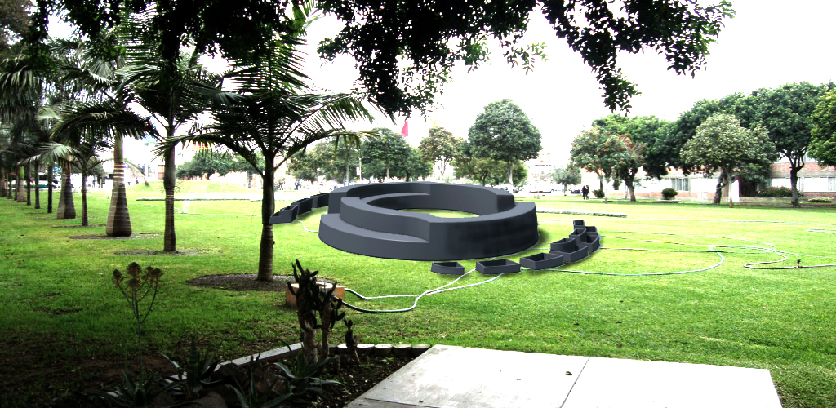
3D DESIGN IN MAIN PUCP GARDEN SETTING
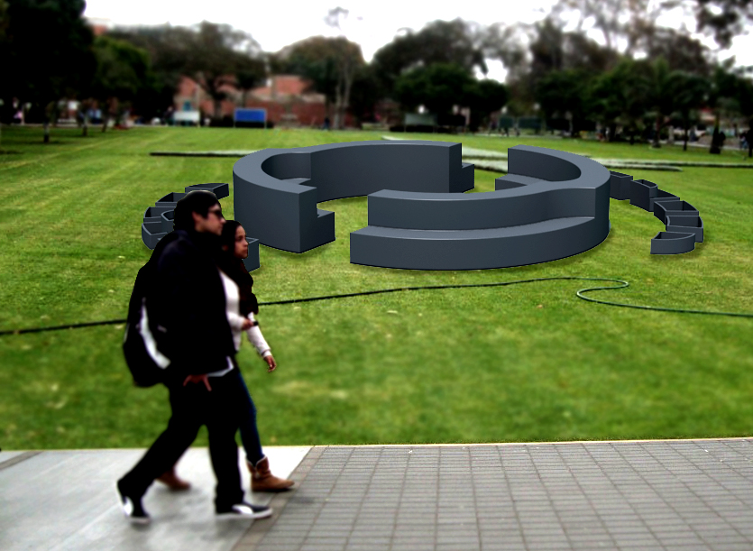

PLAN FOR TEST – PILOT
PUCP university will be the one financing this project, this is because all the arrangements produced by the students and PUCP community members will remain and decorate the university, giving a better look to our installations. It’s a give and take situation: the university gets "happy gardening workers₺ and gives the rest of us, beautiful flowerpots all around the campus.
During design day there will be someone in charge the activity taking care of the flowers, plants, pots, and other accessories they might require (gardening scissors for example), and making sure no one breaks anything or take something they shouldn’t, as well as answering any doubt anyone might have.
PuntoEdu’s supplement, ₺Q" will help us with the diffusion of the event as well as announcing the months’ winners, this will make the students more interested in our project and make them want to participate.
INTERVIEW FORMAT

• What do you think of the social contact at the Campus?
• Do you understand our concept? What’s your general opinion about it?
• Do you think it stimulates Face to Face relations?
• Would you use it?
• Do you have any idea or suggestion to help us improve it?
• Do you think it’s possible to do something like this in our university?
• What would you say is the most interesting element in our project?
• Who do you think would get more benefit from this? Who would be more interested? (Use and would like to spend their time in this place).

INTERVIEW RESULTS
The results show that most of the PUCP community members will be happy with a space like this. Three of them said that they wouldn’t go to work with the flowers but that it will sure be beautiful to walk around the campus and be surrounded by flower arrangements. They think that working with your friends on an a different activity like this will give them the opportunity to do something different during their "cultural Thursdays₺.
Overall the response was positive; they think that this project will adapt great to the university and that promoting the maintenance of green areas is a good initiative.

When asked about what they considered the most important element in the project, most of them answered that exhibiting the arrangements around the campus is a good idea because the participants will feel that the university is recognizing their effort, as well as the other PUCP community members.
The interviewed people think that this is a very open project that tries to congregate the whole PUCP community , so they don’t really think about one type or people when asked who they thought would like this place the most. That’s the great thing, we can all participate from this.

CONCLUSION
Designing a project like this from the beginning was complex, yet interesting because we were the ones, based on a concept: mobile gardens, to decide what was going to be the event or activity that required this to happen and not just making the design.
Being in charge of creating the environment and necessity is something that we hadn’t done before; the design approach is different than the one we are used to work with, which has more parameters and focuses on the interaction between the product and the user, with a context that is already designed.
We believe that the project we’ve developed could actually take part at our university, especially because of the importance it gives to maintaining the green areas in the campus. It doesn’t require from a large sum of money for it to happen, PUCP won’t have to spend a lot and the benefits it’ll receive are going to be large because of the good publicity it represents to the university.
Letting the PUCP community members take the flowers and plants before they get bad it’s a nice idea that promotes people to take care of the environment. It doesn’t cost anything to the university and its better than just throwing them to the garbage, it gives people a sense that they are receiving something from PUCP.
Overall this has been a really nice experience that has taught us a methodology that we had never applied and after developing the whole project find really useful because it helps us to understand step by step how to concrete a project in the real life, taking into consideration not only design variables.

